**Download dados MODIS**

## Solicitando os dados

https://ivfl-info.boku.ac.at/results

2000 - ok

2001 - ok

2002 - ok

2003 - ok

2004

2005

2006

2007

2008

2009

2010 - ok

2011 - ok

2012 - ok

2013

2014 - ok

2015

2016

2017

2018 - ok

2019

2020

2021

2022

## Programa para baixar os dados após finalizar o processamento no site

<https://filezilla-project.org/>

**Configurando o filezilla**

1. Conectar o site (https://ivfl-info.boku.ac.at)

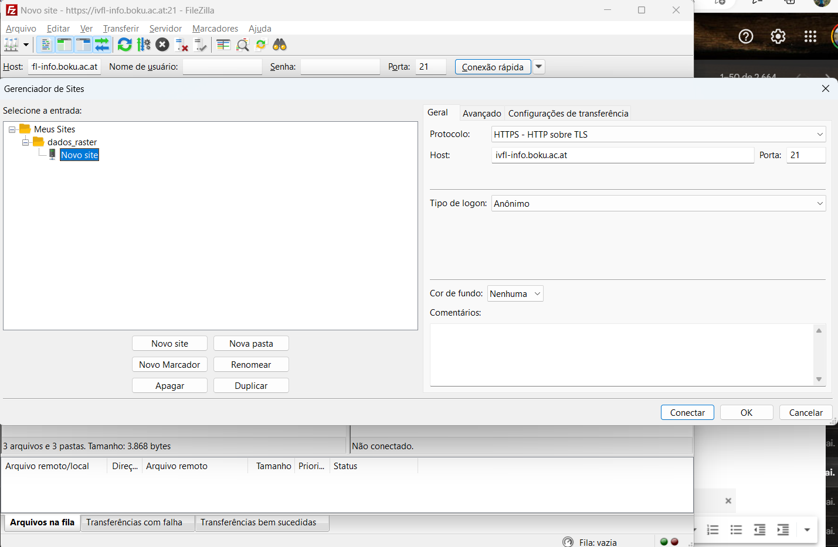

1. Conectar o Host: (Ex.: ftp://141.244.38.19/efda849b885e8f9717571aa02e62a944/)

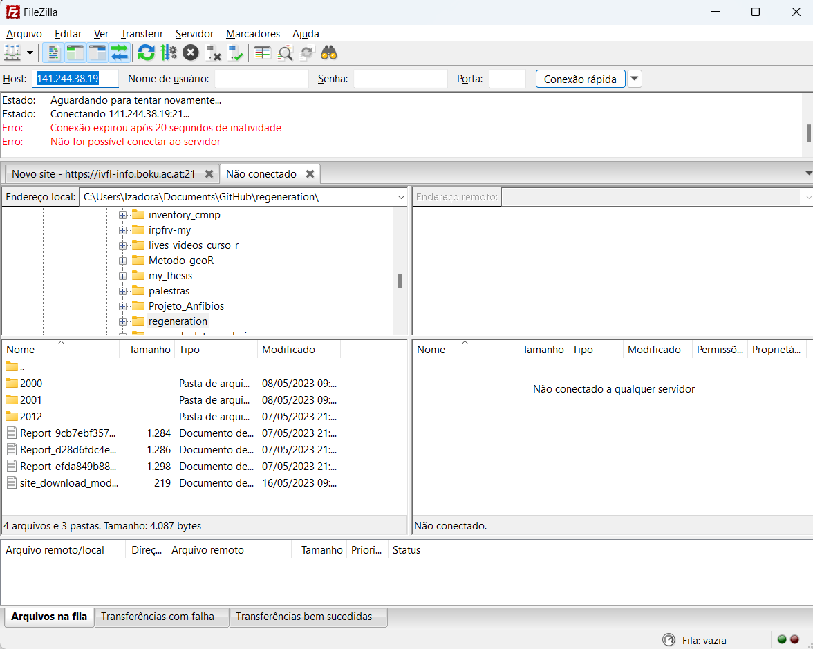

O link ftp é o obtido no site: [On-demand NDVI & EVI (Global) (boku.ac.at)](https://ivfl-info.boku.ac.at/results)

